REGATTA NAME
Month DD – DD, Year
Organizing Authority: Hobie Class Association of North America, Hobie Division XX and Hobie Fleet XXX
hosted by: Club Name, Site, City, State, Province, Country (USA, CAN, MEX, GUA)
SAILING INSTRUCTIONS
The notation ‘[DP]’ in a rule in the SI means that the penalty for a breach of that rule may, at the discretion of the protest committee, be less than disqualification.
The notation ‘[NP]’ in a rule in the SI means that instruction is not grounds for protest or a request for redress by a boat. This changes rule 60.1.

- RULES
  - The regatta shall be governed by the rules as defined in The Racing Rules of Sailing (RRS).
  - US Sailing Prescriptions to RRS 40 shall not apply.
- NOTICES TO COMPETITORS & INFORMATION MEETING(S)
  - Notices to competitors will be posted on the official notice board located [notice board location]
  - There will be a Competitor’s Meeting [date, time and location]
  - Other competitors’ meetings may be scheduled as required.

CHANGES TO SAILING INSTRUCTIONS
Any change to the sailing instructions will be posted not less than 60 minutes prior to the first scheduled race on the day it shall take effect, except that any change to the schedule of races will be posted by 1800 on the day before it shall take effect or the protest time limit of the previous day it shall take effect, whichever is later

SIGNALS MADE ASHORE
  - Signals made ashore will be displayed [location of signals ashore].
  - When flag AP is displayed ashore, ‘1 minute’ is replaced with ‘not less than 30 minutes’ in race signal AP. This changes Race Signal AP.
- SCHEDULE OF RACES
  - There shall be X days of racing (Month/DD – Month/DD) - with 3 to 5 races per day.
    - Hobie XX and Hobie XX – (Month/DD – Month/DD)
  - The scheduled first warning signals will be:
    - Month/DD – 1200
    - Month/DD – Month/DD – 1100
    - On [Day of Week}– (Month/DD), there will be no warning signal after 1500.

CLASS FLAGS
  - Class flag will be:
    - Hobie 14 – Purple background with a White Flying Hobie H
    - Hobie Waves – Yellow background with a Black Flying Hobie H
    - Hobie 17 – Green background with a Black Flying Hobie H
    - Hobie 18 – White background with a Black Flying Hobie H
- RACING AREA
The racing area will be located [area].

THE COURSES
  - HCA Standard Courses will be used. Reference Addendum A and B for course geometry
  - The “G” option will not be displayed by the RC. The leeward mark may be a single mark or a gate. If the leeward mark is a single mark, it shall be left to port.
  - No later than the warning signal the RC may display the approximate compass bearing and distance of the first leg.

MARKS
  - Rounding marks will be:
    - Outside Course: Mark A: Yellow Inflatable mark.
    - Inside Course: Mark A: Orange Inflatable mark.
    - Mark C/Gate: Yellow inflatable marks.
  - Outside Course: New mark: Green Inflatable mark as provided in SI 12.1.
  - Inside Course: New mark: Orange Inflatable Tetrahedron as provided in SI 12.1.
  - The starting and finishing marks will be Orange inflatable marks, or float with a staff displaying an Orange flag.
- AREAS THAT ARE OBSTRUCTIONS
[RESERVED]
- THE START
  - The starting line will be between a staff displaying an Orange flag on the RC Signal Vessel and the course side of the starting mark as described in Instruction 9.4.
  - Boats whose warning signal has not been made shall avoid the starting area during the starting sequence for other races. [DP][NP]
  - A boat starting later than four minutes after her starting signal shall be scored Did Not Start without a hearing. This changes RRS A4 and A5. [DP][NP]
- CHANGE OF THE NEXT LEG OF THE COURSE
To change the next leg of the course, the RC will lay a new mark (or move the finishing line) and remove the original mark as soon as practicable. When in a subsequent change a change mark is replaced, it will be replaced by an original mark.
- THE FINISH
  - The finishing line will be between a staff displaying an Orange flag on the RC Signal Vessel and the course side of the finishing mark as described in Instruction 9.4.
  - If the race committee is absent when a boat finishes, she should report her finishing time, and her position in relation to nearby boats, to the race committee at the first reasonable opportunity.
- PENALTY SYSTEM
  - The Two-Turns Penalty is replaced by the One-Turn Penalty. This changes RRS 44.1.
  - APPENDIX V2 will be used.
PENALTY TAKEN AFTER A RACE After a race, a boat that may have broken one or more rules of Part 2 or rule 31 in an incident while racing may take a Post-Race Penalty for that incident. A boat takes the penalty by delivering a written notice to the race office that identifies the race number and when and where the incident occurred. The penalty shall be a 30% Scoring Penalty, calculated as stated in rule 44.3(c). However, rules 44.1(a) and (b) apply, and the penalty shall not be taken after a protest hearing involving the incident has begun.

TIME LIMITS AND TARGET TIMES [DP][NP]
  - Time limits and target times are as follows:
Class | Race Target Time | Race Time Limit | Initial Weather Mark Time Limit | Initial Weather Mark Target Time
All | 45 minutes | 90 minutes | 30 minutes | 8-13 minutes
  - If no boat has passed their initial Weather Mark A within the Initial Weather Mark time limit, the race shall be abandoned.
  - The Race Committee may, at its discretion, award points to a boat equivalent to the boat’s position in a race. The Race Committee determines the method and order. This changes RRS 35, A4 and A5.
- PROTESTS AND REQUESTS FOR REDRESS
  - Protest forms are available at the notice board as described in instruction 2.1. Protests and requests for redress or reopening will be delivered there within the appropriate time limit.
  - For each class, the protest time limit is 60 minutes after the RC Signal Vessel has docked after the last race of the day or 60 minutes after the RC signals “No more racing today,” whichever is later. This changes RRS 61.3 and 62.2.
  - Notices will be posted no later than 30 minutes after the protest time limit to inform competitors of hearings in which they are parties. Hearings shall be held in the protest room, the location of which shall be posted on the official notice board, beginning at the time posted on the notice board.
  - Notices of RC or Protest Committee (PC) protests will be posted to inform boats under RRS 61.1(b).
  - On the last scheduled day of racing a request for redress based on a PC decision shall be delivered no later than 30 minutes after the decision was posted. This changes RRS 62.2.
- SCORING
  - One race is required to be completed to constitute a series.
  - When four (4) or more races are completed, a boat’s series score shall be the total of her race scores excluding her worst score.
- SAFETY REGULATIONS [DP][NP]
  - Competitors shall check in by hailing their sail number to the RC Signal Vessel before the start of the first race each day (and the first race following any postponement ashore). A boat is checked in when the RC acknowledges her by repeating her sail number.
  - A competitor that retires from a race shall notify the RC as soon as possible.
  - Competitors shall wear a life jacket, at all times while on the afloat, except for brief periods while adding or removing clothing. Such device shall verifiably meet the requirements of either the sailor’s national authority or of the government regulations that apply in the racing area. This changes RRS 40. The penalty for failure to comply with this rule shall be at the discretion of the protest committee, and may result in disqualification.
  - Competitors from outside the U.S. may wear a life jacket approved by their nations’ certification authority to the extent permitted by international treaty.
  - The life jacket must be worn outside of all clothing except that a thin shirt may be worn over the life jacket to prevent snagging. The life jacket may also be worn in such a way that a full trapeze harness is secured over the life jacket.
REPLACEMENT OF CREW OR EQUIPMENT [DP][NP]
  - Substitution of competitors shall not be allowed without prior written approval of the Race Committee.
  - Substitution of damaged or lost equipment shall not be allowed unless authorized by the Race Committee. Requests for substitution shall be made to the Race Committee at the first reasonable opportunity.
- EQUIPMENT AND MEASUREMENT CHECKS [DP][NP]
A boat or equipment may be inspected at any time for compliance with the class rules and sailing instructions. On the water, a boat can be instructed by a member of the RC to proceed immediately to a designated area for inspection.

RADIO COMMUNICATION [DP][NP]

Boats may carry a marine band VHF receiver capable of receiving international channels. All radio communications between the RC and Competitors will be on VHF channel XX.

Various race information may be provided by the RC as a courtesy to competitors. This does not in any way alter the competitor’s responsibility to observe the RC’s visual signals which shall govern the conduct of the racing.

Except in an emergency and before the first Warning Signal on each race day until the end of the last race of the day, a boat that is racing shall not make voice or data transmissions and shall not receive voice or data communication that is not available to all boats.
- AWARDS
  - Awards will be presented at the Awards Ceremony after the conclusion of racing on the last day of the event.
  - The winner of each class shall be declared the XXXX Champion for that class.
- DISCLAIMER OF LIABILITY
Competitors participate in the regatta entirely at their own risk, See RRS 4, Decision to Race. It is the personal responsibility of each competitor to determine their level of safety. The organizing authority shall not accept any liability for material damage or personal injury or death sustained in conjunction with, prior to, during, or after the regatta.

INSURANCE
Each participating boat shall be insured with valid third-party liability insurance with a minimum coverage of $100,000 (USD) per event or the equivalent.
- SPECIAL NOTES
  - Any boat receiving ‘hands on’ assistance from rescue/mark vessels shall be scored Did Not Finish. This changes RRS rule A5. The RC may decide when a boat or crew needs assistance.
  - The RC may request redress for competitors who exhibit extraordinary sportsmanship.
SAFETY NOTES TO ALL SAILORS
WHILE THE EVENT SITE IS CLEAR OF ELECTRICAL POWER LINES, WHEN OFF-SITE – AVOID!!!
Whenever off-site whether raising or lowering a mast, while sailing, or moving your boat over land ALWAYS check for and avoid low overhead electrical power lines. If you see a power line, AVOID IT! A MAST COMING IN CONTACT OR EVEN NEAR AN ELECTRICAL POWER LINE CAN CAUSE SERIOUS INJURY OR DEATH TO PEOPLE ON OR TOUCHING THE BOAT!
Addendum A – Illustrating the Course
No. Course Finish
1 (S) A C/GATE A (F) Downwind
2 (S) A C/GATE A C A (F) Downwind
3 (S) A C/GATE A B C/GATE (F) Upwind
4 (S) A C/GATE A B C/GATE A (F) Downwind
5 (S) A C/GATE (F) Upwind
6 (S) A C/GATE A C/GATE (F) Upwind
7 (S) A C/GATE A B C A C/GATE (F) Upwind

S = Start, A = Weather Mark, B = Reaching Mark, C = Leeward Mark, GATE = GATE, F = Finish

NOTE: Colors and/or shape of marks used in illustrations may not accurately represent the actual color or shape of marks used on the actual race course. Refer to SI 9, 11 and 13.
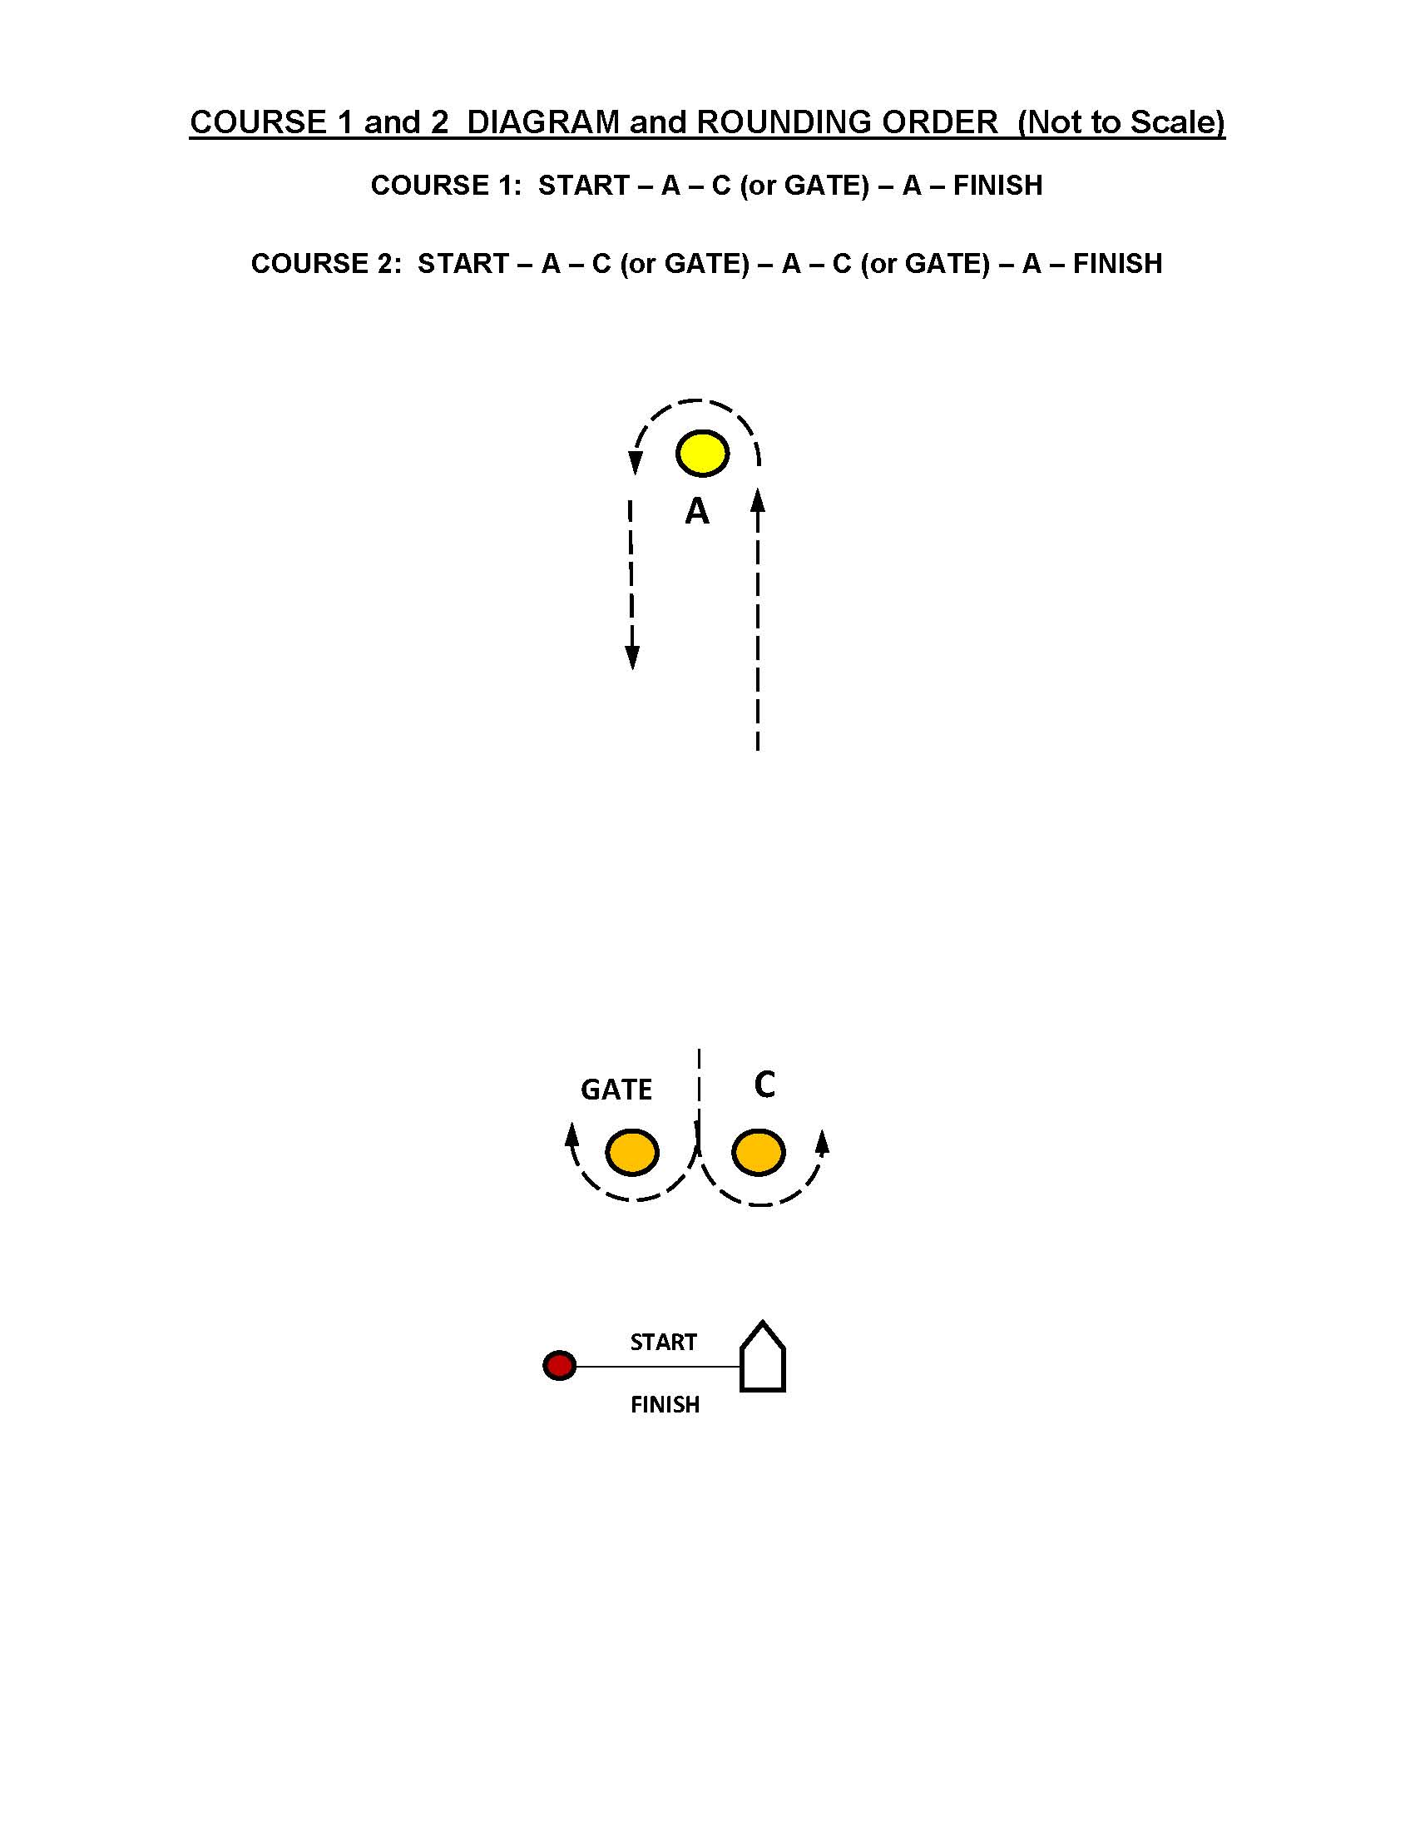
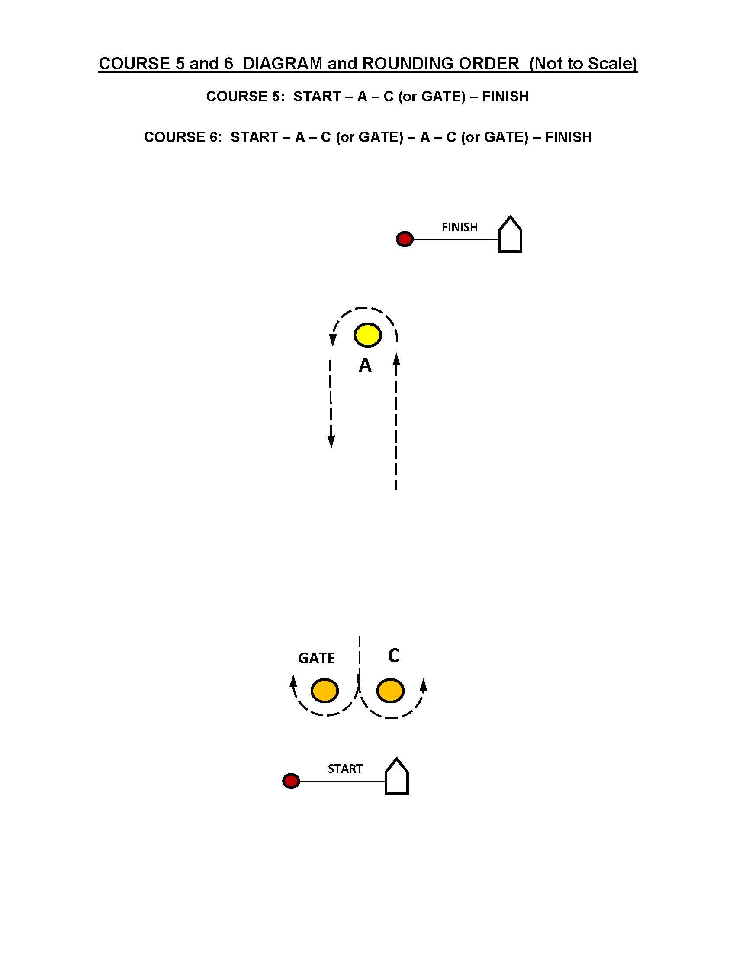

Addendum B – Illustrating the Optional Wave Course
No. Course Finish
1W (S) A B C/GATE A (F) Downwind

NOTE: Colors and/or shape of marks used in illustrations may not accurately represent the actual color or shape of marks used on the actual race course. Refer to SI 9, 11 and 13.
C
GATE
A
A
B

START
FINISH
Addendum C – Racing Area

[INSERT MAP OF RACING AREA]

